Forms

Definition:
# Source: AI Source: Provided by: [Data Path: Persons Table -> ID Column: 1, Name_En Column: Motasem Essam] -> From: [Chatgpt (GPT‑5 Mini)] on [2/12/2026]
Forms are web page components that allow users to input and submit information to a website. They are essential for collecting data, interacting with users, and completing transactions.

Simple Definition
# Source: AI Source: Provided by: [Data Path: Persons Table -> ID Column: 1, Name_En Column: Motasem Essam] -> From: [Chatgpt (GPT‑5 Mini)] on [2/12/2026]
Forms = sections on a web page where users can enter information, such as names, emails, messages, or search queries.

What Forms Usually Include
# Source: AI Source: Provided by: [Data Path: Persons Table -> ID Column: 1, Name_En Column: Motasem Essam] -> From: [Chatgpt (GPT‑5 Mini)] on [2/12/2026]
- Input fields – text boxes, email, password, phone number
- Radio buttons / Checkboxes – select options
- Dropdown menus – choose from multiple options
- Text areas – for longer messages or descriptions
- Submit button – sends the information
- Captcha / Verification (optional) – prevent spam or bots

Purpose of Forms
# Source: AI Source: Provided by: [Data Path: Persons Table -> ID Column: 1, Name_En Column: Motasem Essam] -> From: [Chatgpt (GPT‑5 Mini)] on [2/12/2026]
- Collect user information (contacts, feedback, orders)
- Allow users to interact with the website
- Facilitate transactions, registrations, or subscriptions
- Enhance user engagement and communication

Examples
# Source: AI Source: Provided by: [Data Path: Persons Table -> ID Column: 1, Name_En Column: Motasem Essam] -> From: [Chatgpt (GPT‑5 Mini)] on [2/12/2026]
- Contact form → name, email, message
- Registration / sign-up form → name, email, password
- Checkout form → billing and shipping details
- Feedback form → comments or ratings
- Search form → keyword input to find content

Difference Between Forms and Buttons / CTA
# Source: AI Source: Provided by: [Data Path: Persons Table -> ID Column: 1, Name_En Column: Motasem Essam] -> From: [Chatgpt (GPT‑5 Mini)] on [2/12/2026]
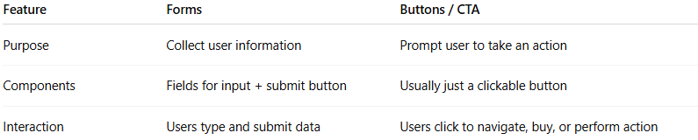
Feature | Forms | Buttons / CTA
Purpose | Collect user information | Prompt user to take an action
Components | Fields for input + submit button | Usually just a clickable button
Interaction | Users type and submit data | Users click to navigate, buy, or perform action

